**PROJECT**

(Deep Learning Model)

**"LeafScan: Automated Leaf Disease Detection Using**

**Convolutional Neural Networks"**

**By**

Name: Pretty

Group: 4NC7

Roll No: 102295004

**Submitted To:**

Dr. Neeru Jindal

Department of Electronics and Communication Engineering

THAPAR INSTITUTE OF ENGINEERING & TECHNOLOGY, PATIALA, PUNJAB

JUNE 2024

* **Introduction :**

In agriculture, maintaining crop health is crucial for productivity, and early disease detection plays a vital role in this. Traditional methods of identifying plant diseases rely heavily on visual inspection, which is time-consuming, requires expertise, and may be infeasible for large-scale farms. This project, **LeafScan**, leverages the power of deep learning, particularly Convolutional Neural Networks (CNNs), to automate the detection of diseases from leaf images, offering a scalable and efficient solution.

* **Problem Formulation:**

Agricultural productivity is often hindered by the lack of readily available and accurate diagnostic tools for plant diseases. Visual inspection is not only resource-intensive but also prone to human error. Delay in disease diagnosis can lead to increased crop loss and reduced yields. This project aims to address these limitations by providing an automated, cost-effective solution to disease detection, improving accessibility and accuracy in crop monitoring.

* **Novelty Statement:**

This project stands out by combining a custom convolutional model with a transfer learning approach, maximizing classification accuracy. The model’s adaptability to various leaf diseases enhances its applicability across multiple plant species, making it unique among similar studies.

* **Objective:**
* To develop a CNN-based model capable of identifying multiple plant diseases with high accuracy.
* To leverage transfer learning to enhance the performance of the disease detection system.
* To offer a scalable and user-friendly solution for real-time disease diagnosis in agriculture.
* **Methodology:**
* **Data Collection and Preprocessing**: Images were collected and resized to a uniform 150x150 pixels. Normalization was applied to scale values from 0–255 to 0–1, making the data suitable for deep learning models. Images were converted into arrays for model input.
* **Model Development**: A CNN model with Conv2D, MaxPooling2D, and Dropout layers was built to capture complex features in the images. Additionally, a pretrained model was used to incorporate transfer learning, allowing the model to leverage learned features effectively.
* **Training and Evaluation**: Data was split into training and test sets, with model performance evaluated on accuracy, precision, and recall. Evaluation metrics provided insight into the model’s ability to differentiate between healthy and diseased leaves accurately.
* **Approach:**
* **Data Preprocessing:** Resized images to 150x150 pixels and normalized pixel values (0-255 to 0-1). Encoded images as numpy arrays for model compatibility.
* **Modeling (Custom CNN):** Used Conv2D, MaxPooling2D, Dropout, and BatchNormalization layers, ending with dense and softmax layers for multi-class classification.
* **Evaluation:** Split data into training and testing sets. Assessed performance with accuracy, confusion matrix, and classification report.
* **Implementation & Simulation Results:**

**1.1 Package and Library**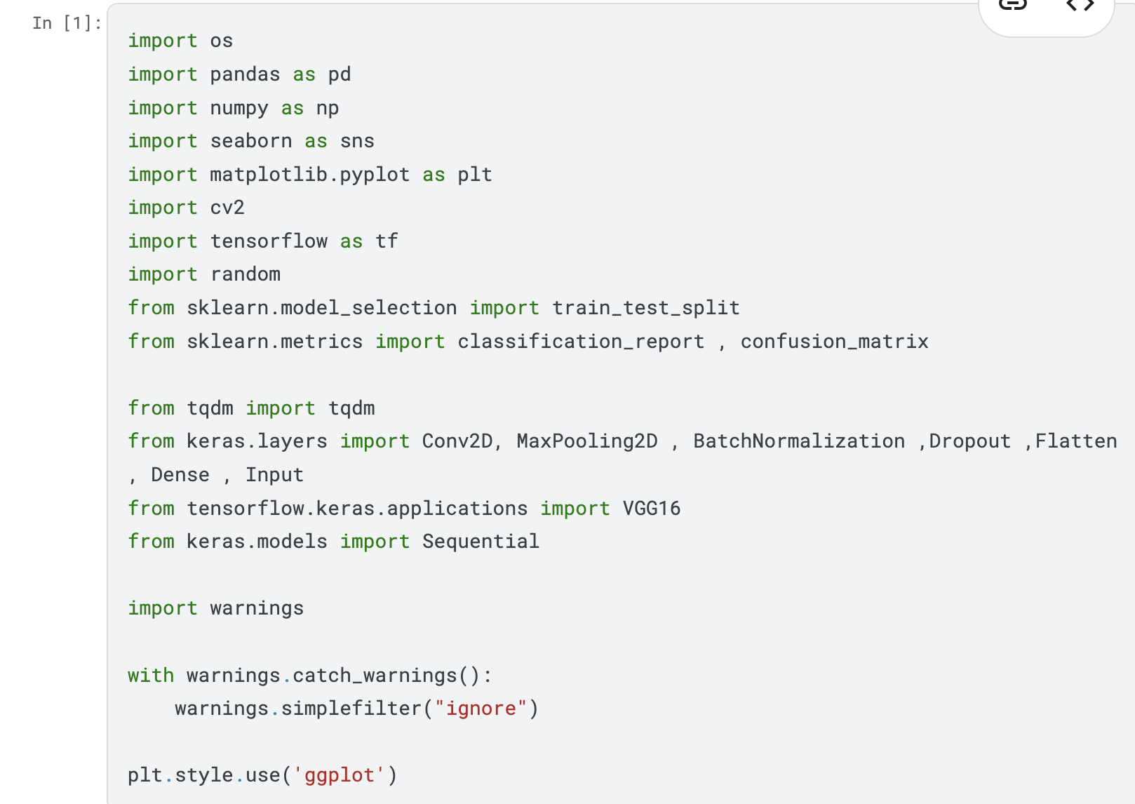

**1.2 Load the Data**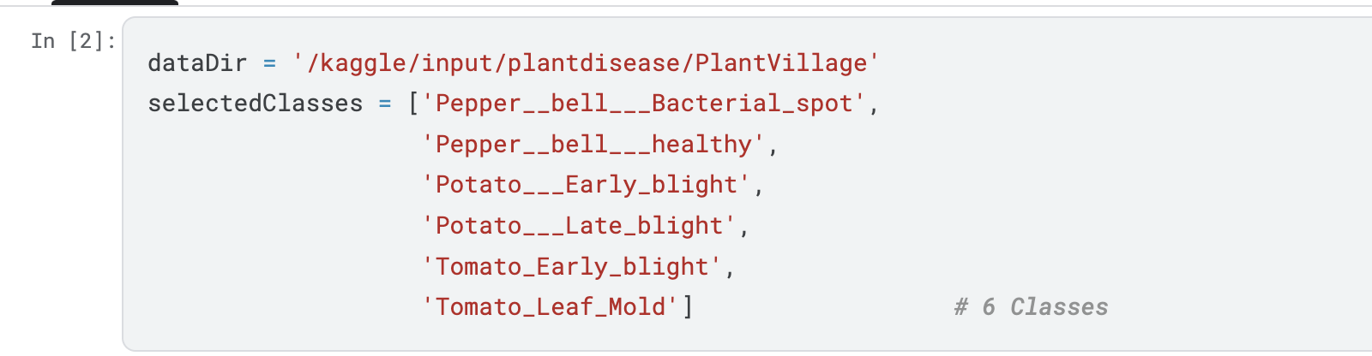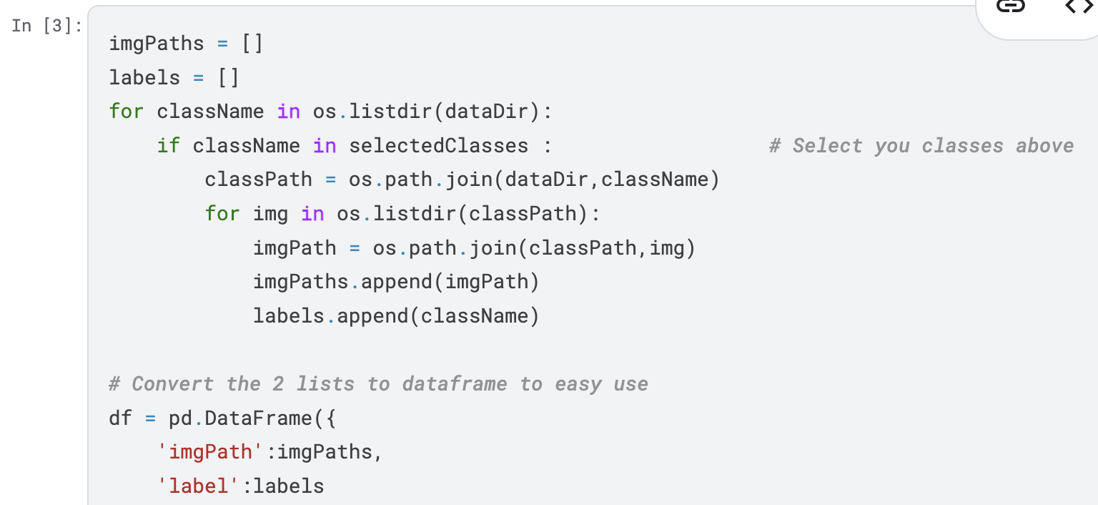

**1.3 Data Explorations**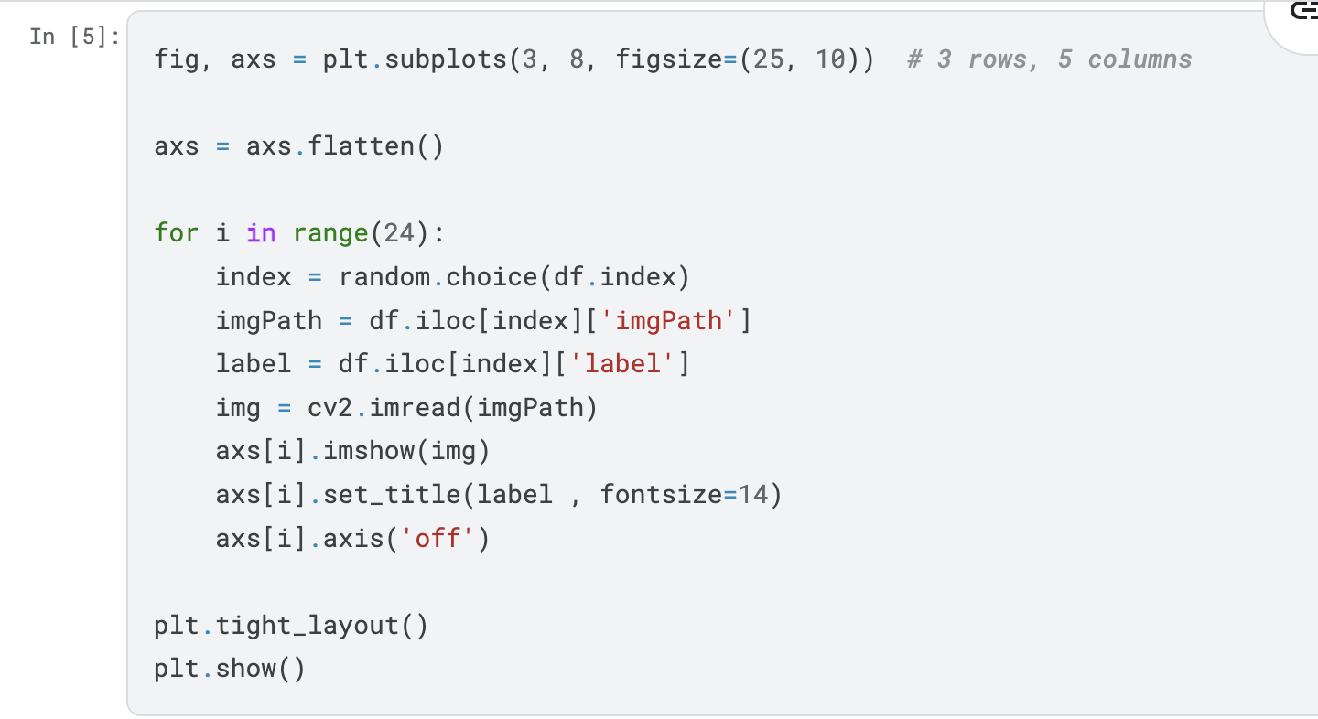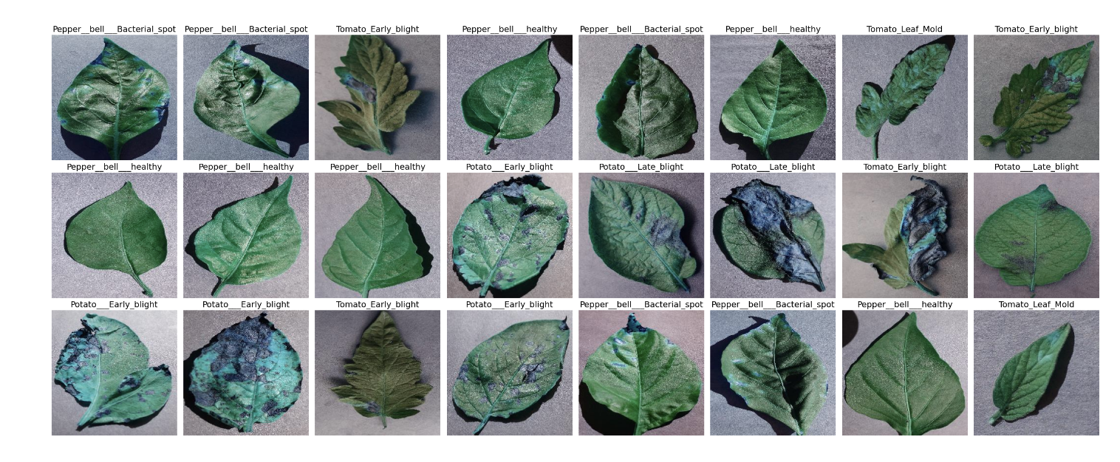

**1.4 Image 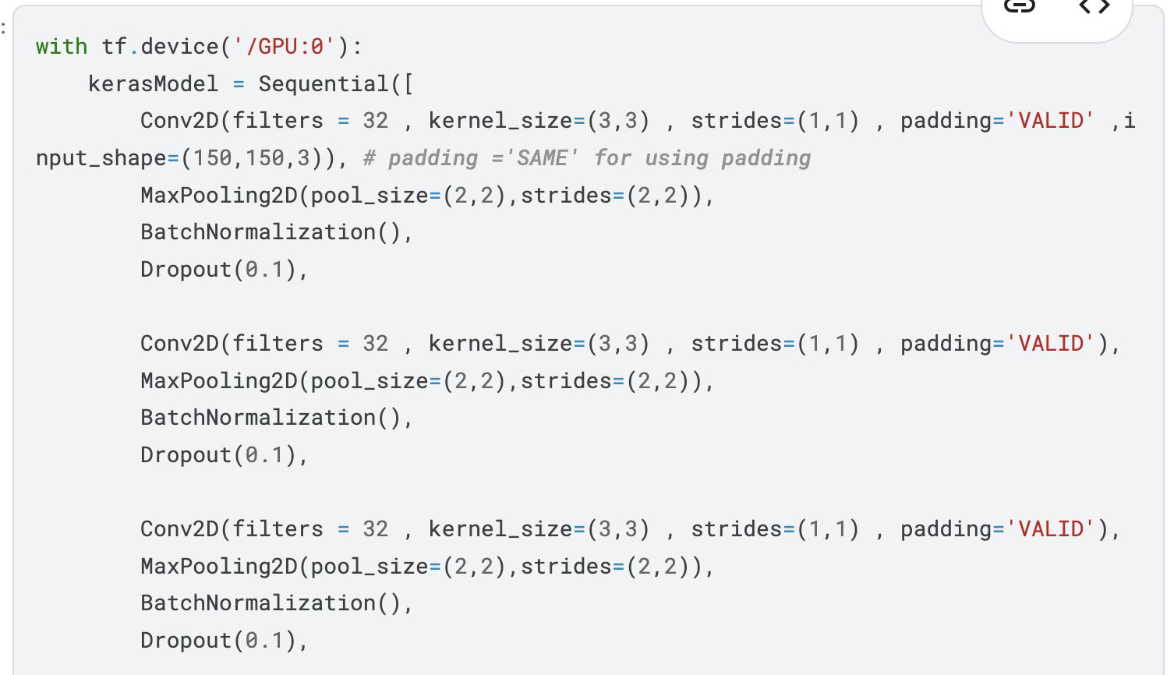Processing**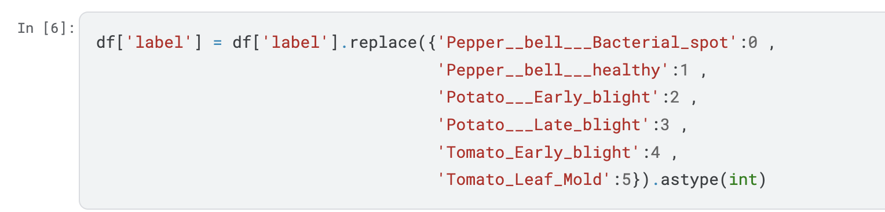

**1.5 CNN Model**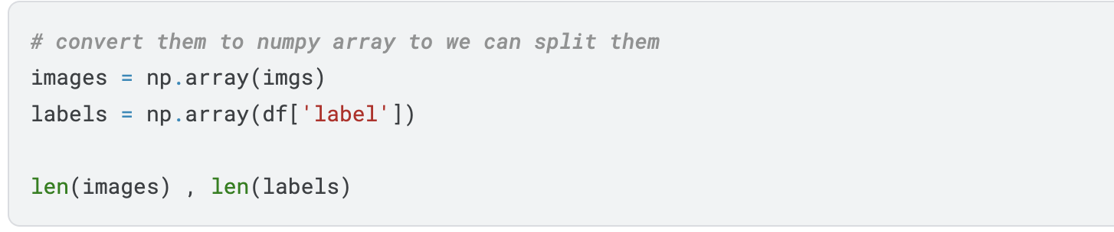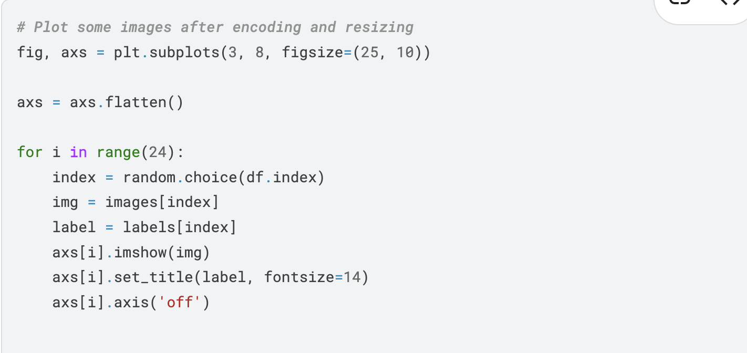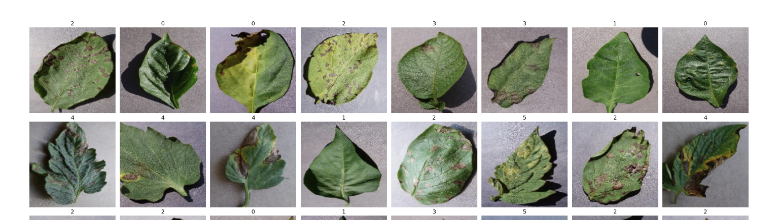

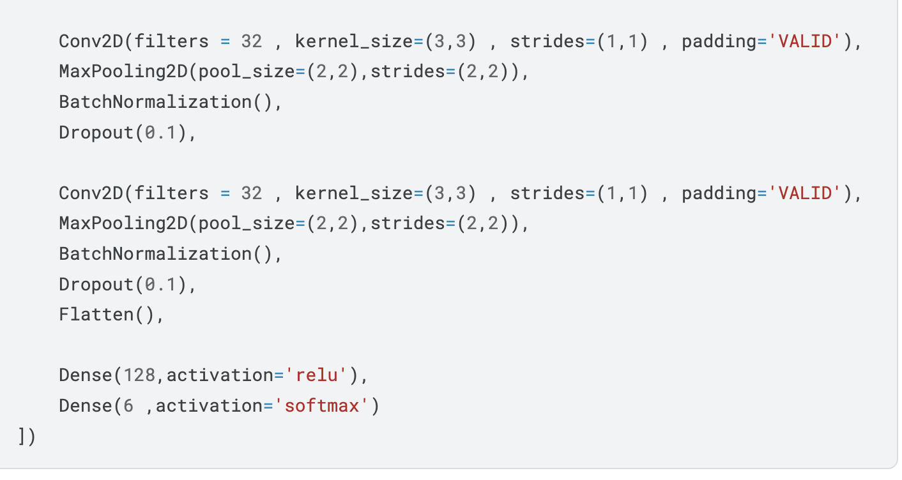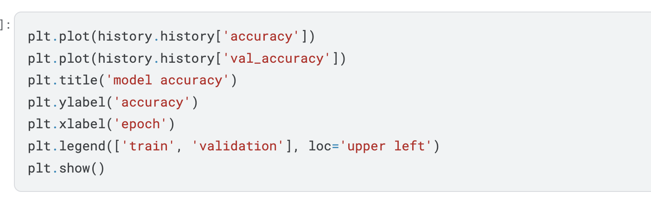

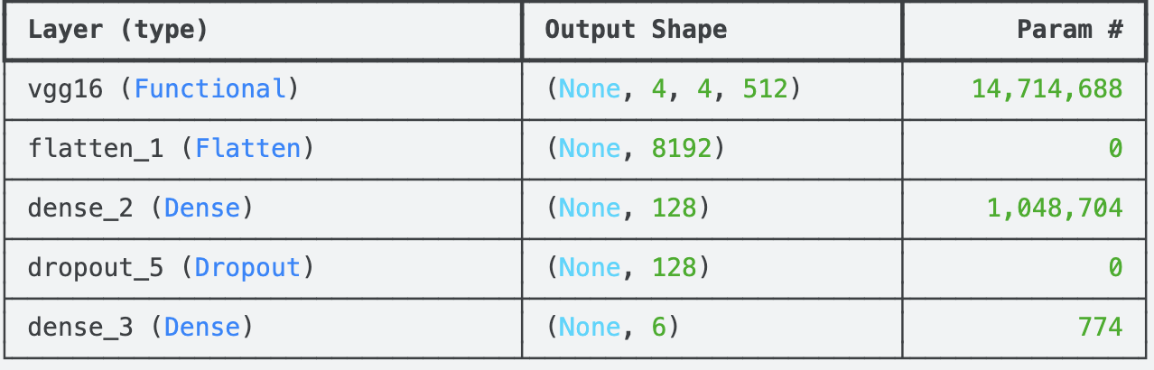

Fig: Model Summary

Fig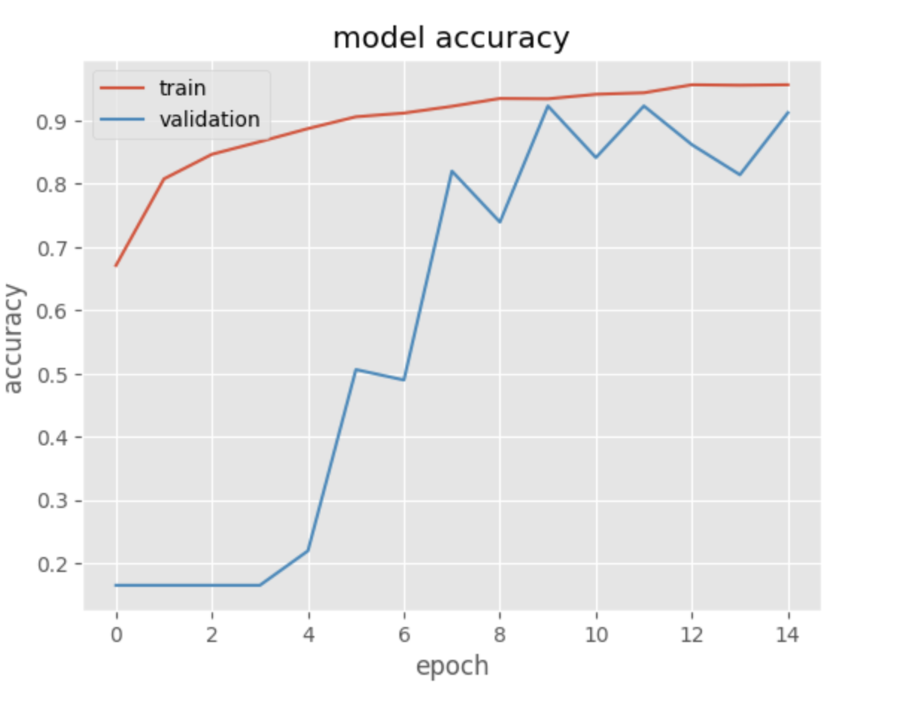: Model Accuracy

**1.6 Performance Evaluation:**

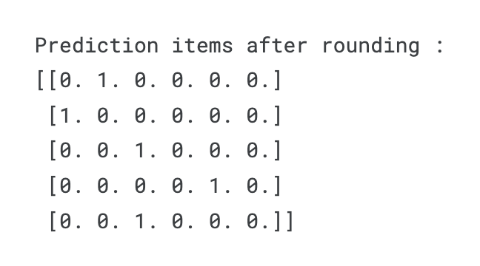

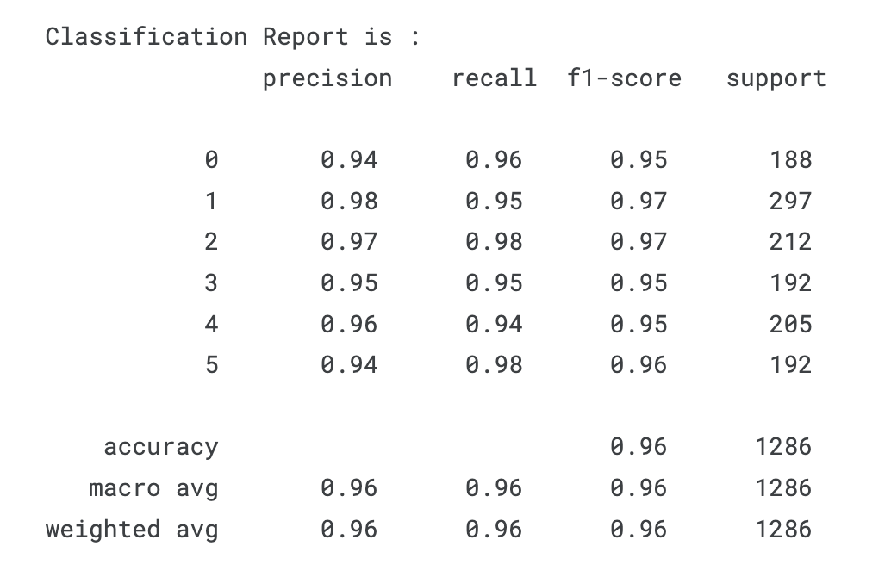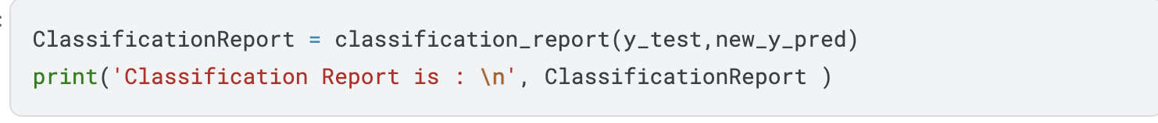

* **Challenges:**

1. **Class Imbalance**: Addressing the issue of potential class imbalance, which affect model accuracy for underrepresented classes.
2. **Overfitting**: Preventing overfitting by applying dropout and early stopping mechanisms.
3. **High Variability in Image Conditions**: Images may vary in lighting, angles, and plant orientation, affecting the model's ability to generalize.

* 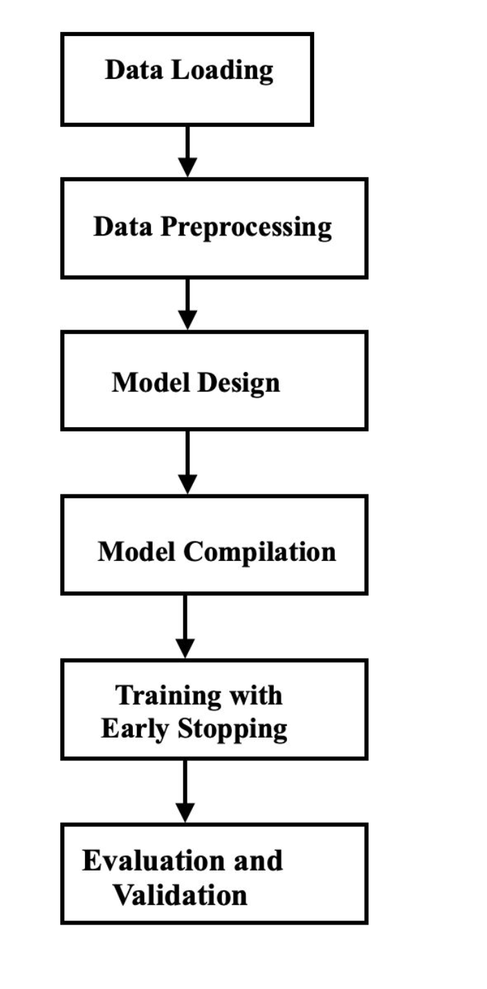**Flowchart:**

* **Conclusion:**

This project demonstrates the effectiveness of deep learning in automating plant disease detection. By using both a custom convolutional model and a transfer learning approach, we achieved high accuracy in classifying multiple plant diseases from leaf images. The model’s performance, evaluated through accuracy metrics and classification reports, shows it to be a scalable and efficient alternative to traditional manual inspection methods. LeafScan offers a practical solution for early and accurate disease identification, providing substantial benefits for crop health monitoring .